Project/Problem Based Learning Template

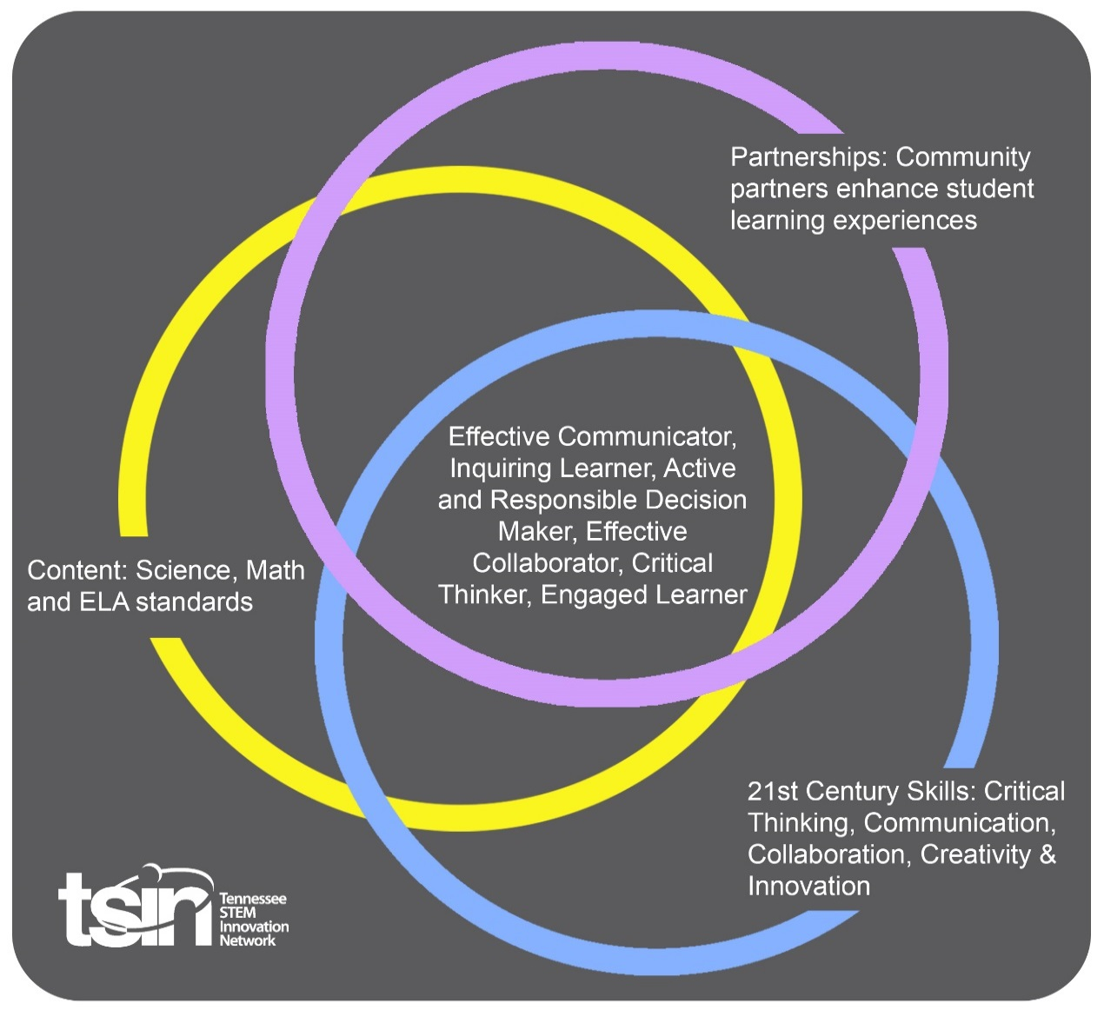

|  |  |  |  |
| --- | --- | --- | --- |
| **Created By:** | **Topic:** | | **Grade Level or Subject:** |
| **Science Standards:** | | | |
| **Math Standards:** | | | |
| **ELA Standards:** | | | |
| **Additional Standards (Social Studies, Art, Physical Education):** | | | |
| **PBL Summary:** Write a few sentences describing this PBL unit. | | **Multi-Dimensional/Driving Question:** Think of a relevant problem with multiple solutions that will drive student learning. | |
| **Tennessee Academic Standards for Science Connection** | | | |
| Disciplinary Core Idea(s): | Science & Engineering Practice(s): | | Cross Cutting Concept(s): |
| **21st Century Skills Addressed (circle all that apply):**  Creativity Collaboration Critical Thinking Communication | | | |
| **Culminating Event:** What final student learning products will show student mastery of the content area standards? | | | |
| **Hook Event:** Develop an introductory activity that will spark student interest and further questions. | **Community Partners:** List potential business or industry partners that could add to the learning experience for students. Include websites or contact info.  1.  2.  3. | | What do you need from these partners (i.e. guest speaker, field trip, help facilitate an activity)?  1.  2.  3. |
| **Daily Activities:** What activities will students complete to answer the multi-dimensional/driving question (that reinforces content from the standards)?  **Activity:**  1.  2.  3.  4.  5.  6. | | | **Resources/Materials Needed:** |
| **Technology Integration:** How is technology embedded into this PBL unit? | | | |
| **Capstone Presentation:** How will students present what they’ve learned publicly? This can be the culminating event if that event is presenting what has been learned publicly. | | | |

**Performance Based Rubric**

|  |  |  |  |
| --- | --- | --- | --- |
| **Standards** | **Developing** | **On-Target** | **Mastery** |
| Science |  |  |  |
| Math |  |  |  |
| ELA |  |  |  |
| Social Studies |  |  |  |
| Other Content Areas |  |  |  |